Sacred Communication Coaching
Check List

1. Identify the type and purpose of the presentation.
- Sermon: Religious discourse discussing a sacred text in the context of a religious worship service.
- Funeral (Memorial Ceremony, Funeral Service, Grave side Service): Remarks made to remember and honor a Soldier or Family member focusing on the decedent's faith and service, while providing comfort to those in attendance.
- Speech: Oral presentation given in a broader context such as a graduation, a formal dinner address, a patriotic or community event.
- Class: Teaching with discussion in a classroom setting.
- Brief: Presentation for command within the context of a meeting.
- Other: Prayer, Lesson, Counseling, Dialogue etc.

2. Determine how the context affects the presentation.
- Describe the audience and state if attendance is mandatory.
- Assess possible expectations of the audience.
- Identify location and note any environmental details that would affect the presentation.
- Determine the allotted time for both the overall event and the specific presentation.

3. Analyze the three components of the Speaker Assessment Cycle (SAC). (Fig. 1)
- Person: In what ways did the speaker add to or distract from the message? (Examples: dynamic, engaging, focused, distracted, angry, confused, etc.)
- Preparation: Did the message reveal preparation and clear concise thought? (Examples: logical thought, critical thinking, depth of reason, smooth transitions, etc.)
- Presentation: Was the message contextually relevant, within time constraints, and did it accomplish its purpose? (Examples: used appropriate illustrations and terms, understood and adapted to the audience and complied with the time constraints, etc.)
4. Assess the presentation using an appropriate rubric.
- Communication Coaching Form (CCF). (Fig. 2-3)
- SOAR feedback: Situation, Observation, Associate & Assess, Reinforce & Recommend (FM 6-22, paragraph 3-31 & figure 3-3) (Fig. 4)
- Communication Self Evaluation Learning Form (CC-SELF) Presenter's self-evaluation form to be filled out before coaching session with the supervisor. (Fig. 5)
- Others: If desired, a different rubric could be developed from ATP 1-05.02 for funerals and memorials. FM 6-0, figure 7-4 could be used for speeches and briefings. These rubrics need to include clear objectives and specific areas of assessment.
5. Compare supervisor's and presenter's assessments & identify differences.
- Have the presenter watch the video of the presentation, if available, to foster self-awareness and clear understanding of exactly what happened from the perspective of the audience.
- Direct the presenter to use the Communication Coaching Self-Evaluation Learning Form (CC-SELF) or another written form that models the selected rubric (see performance step 4).
- If time does not allow or a written self-assessment is impractical, discuss with the presenter his/her personal assessment of the presentation.
6. Discuss observations, providing specific feedback, & create a development plan to improve skills.
- Discuss presenter's self-assessment by asking future-oriented questions such as: "If you were to present again, what would you do the same & what would you do differently?"
- Provide a written assessment. (CCF or other notes)
- Debrief observations: Be specific, affirm strengths, and provide suggestions for improvement.
- Develop a plan for improved skill in communication addressing observed areas of strength and improvement. Highlight developmental area from SAC to focus future growth.
- Discuss overall impact.

Figure 1 – Speaker Assessment Cycle (SAC)
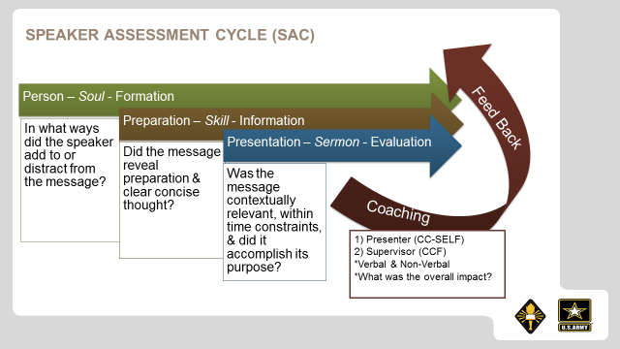
Figure 2 - Communication Coaching Form (CCF) Instructions
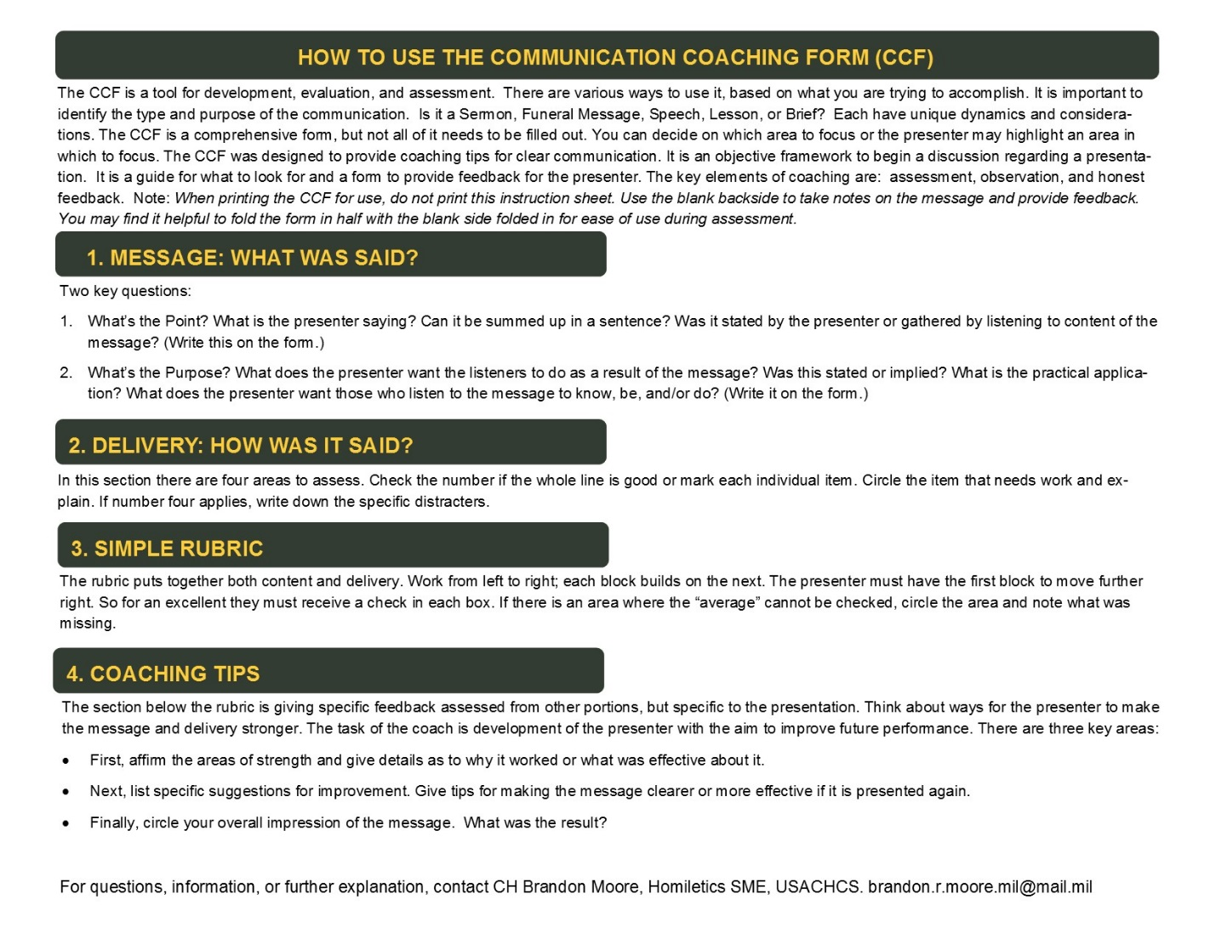
Figure 3 – Communication Coaching Form (CCF) 3.0
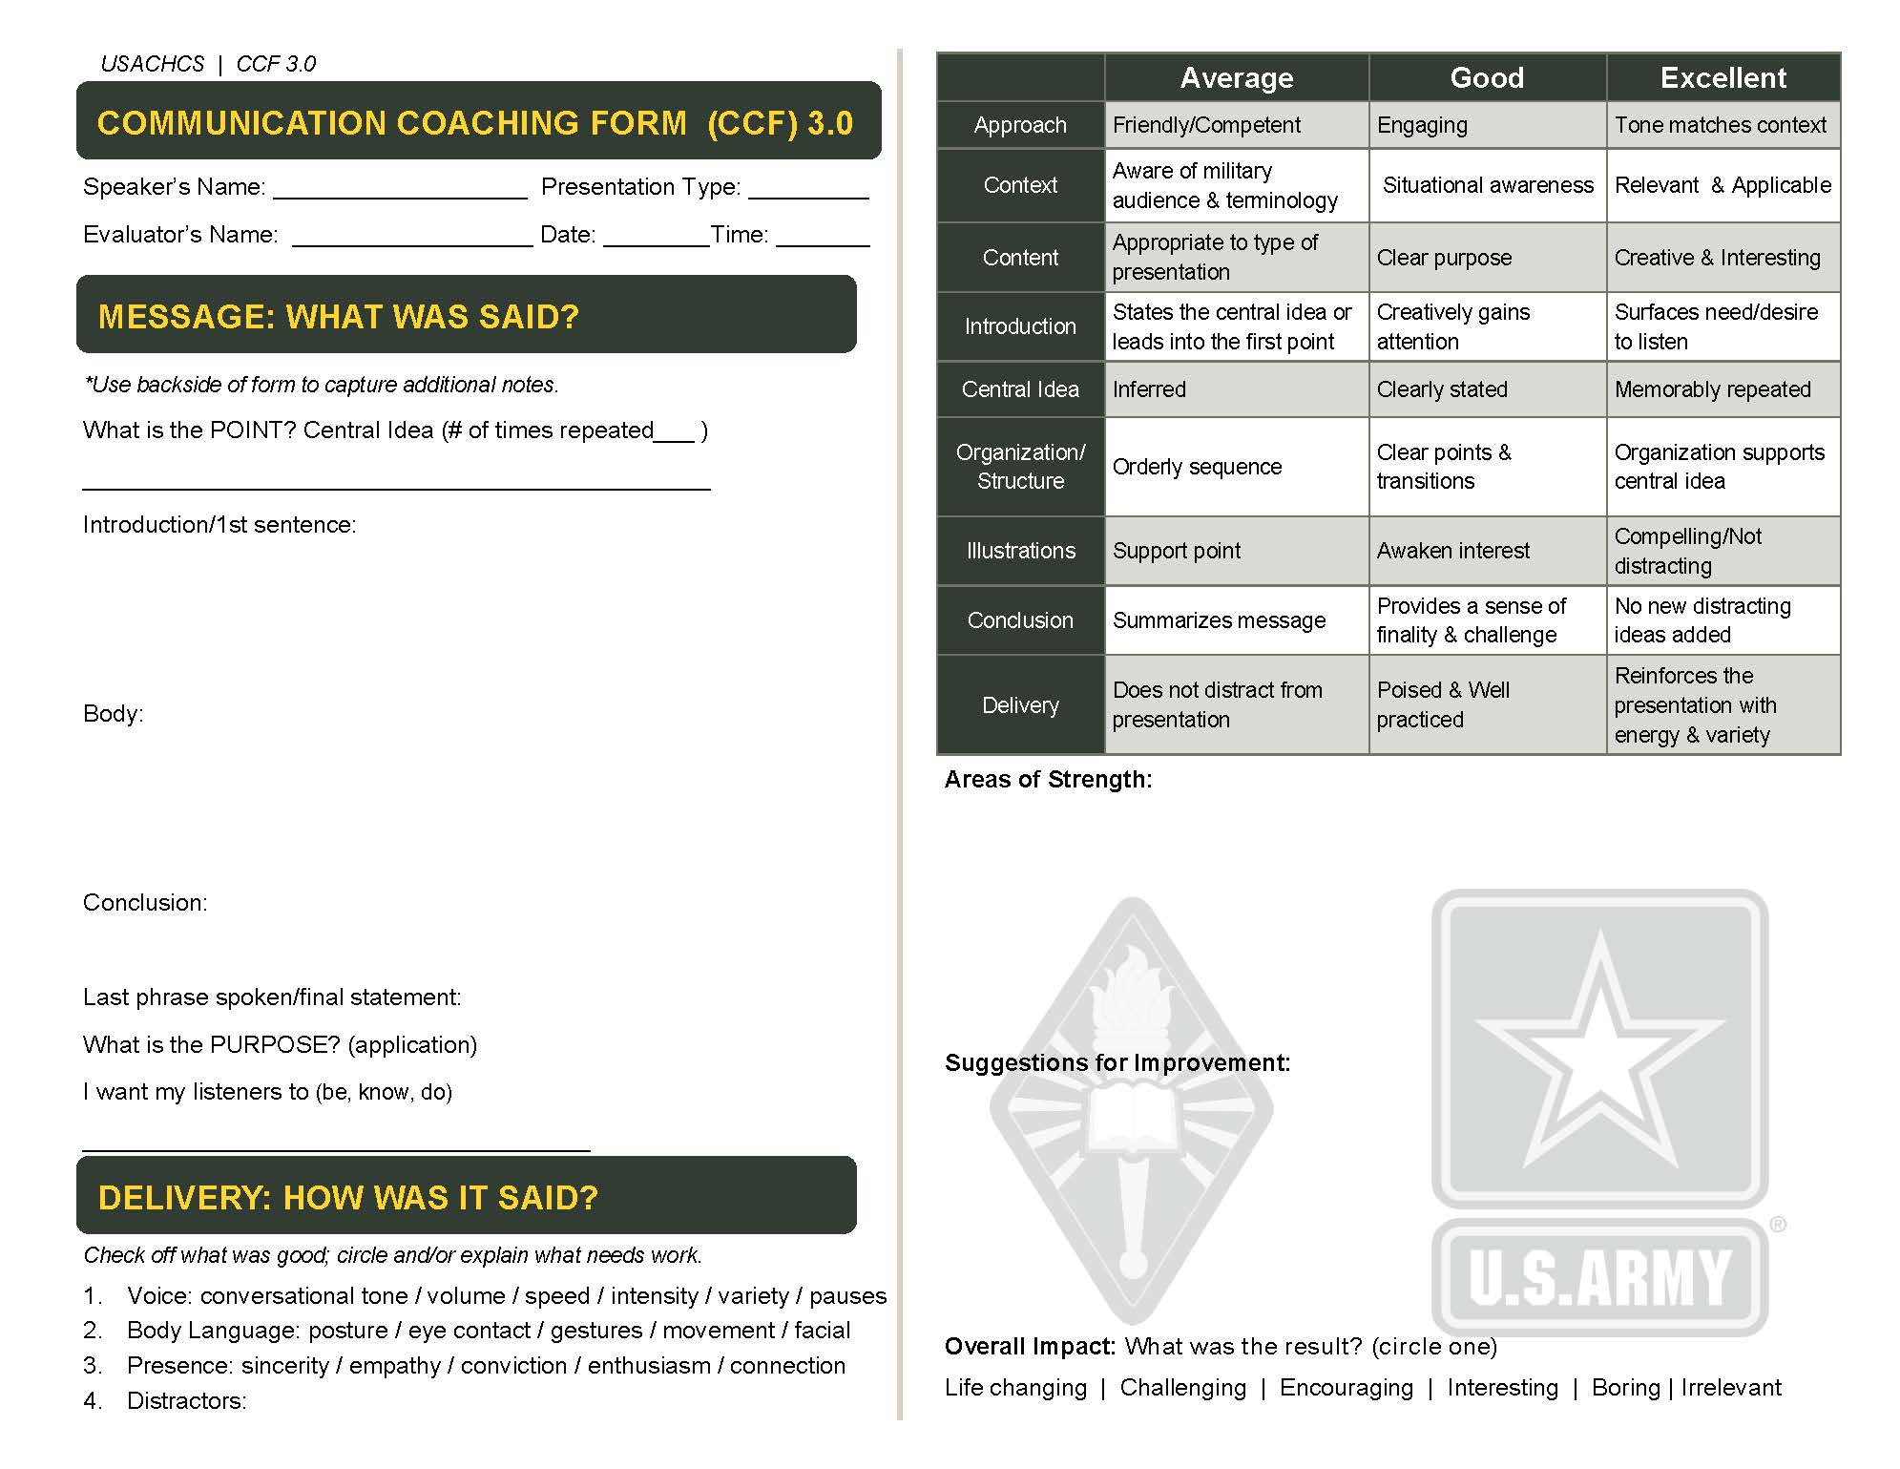
Figure 4 – SOAR Evaluation Matrix Figure 5 - CC-SELF
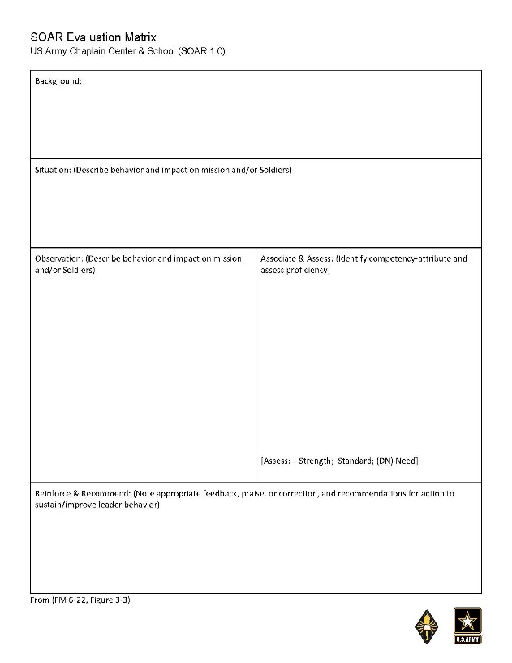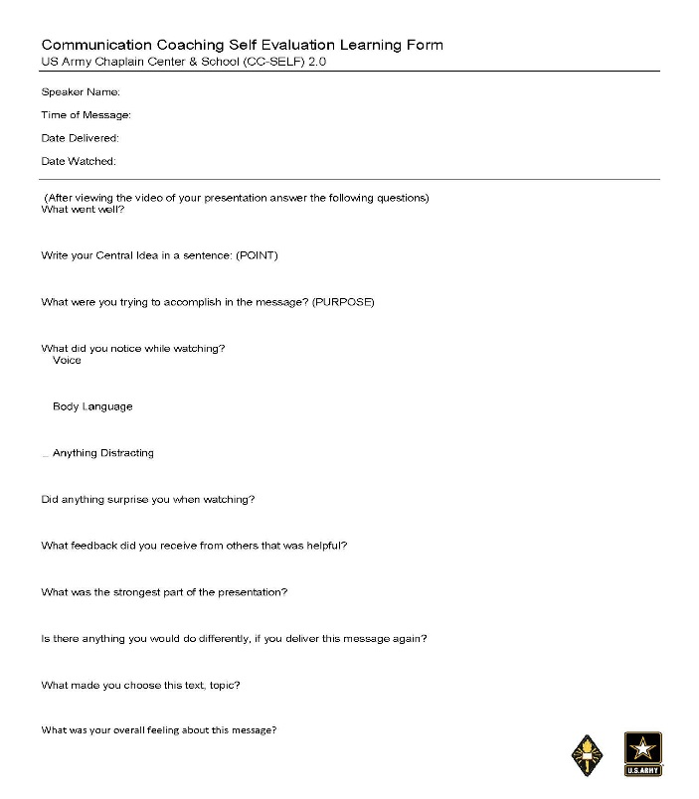

Develop Coaching Principles & Philosophy

 of Communication Coaching

1. We evaluate, assess, & work on the things that are important to us.
2. Sacred Communication is an art and science
3. Coaching is not about duplication, but development
4. Communication Coaching looks at CONTENT & DELIVERY
5. The goal of good coaching is to Improve Future Performance (IFP).

I + C²
T
Intentionality + (Coaching x Care)
Time = Audacious Development of Leaders (ADL)

Other Resources
Peter Jensen, The Winning Factor
http://www.performancecoaching.ca
Michael Bungay Stanier, The Coaching Habit
Gillian Jones & Ro Gorwell , 50 Top Tools for coaching: A complete toolkit for developing and empowering people.

