What are the elements of a Sermon?

TEXT:
CENTRAL IDEA:
PURPOSE:

What’s the Point? (Central Idea)

Subject Question: (What is the author talking about?)
- Ex. Why is CH Moore making us identify the central idea?

Complement Answer: (What is the author saying about what they are talking about?)
- Ex. CH Moore says it is the most important sentence in the sermon and it provides clarity to the listener.

Central Idea: Subject + Complement = Idea
- Ex. We must identify the central idea because it is the most important sentence in the sermon and it provides clarity to the listener.

Creating The Sticky Statement

- Ex. Knowing the Point and Making the Point, Is the Point!

P – Is there a word PICTURE or metaphor?
Ex. You are the light of the world
R – Can I use a RHYME to make it memorable?
Ex. I before E except after C
E – Can I ECHO words or phrases to help it stick?
Ex. Forgiven people forgive
A – Will ALLITERATION drive it home?
Ex. Your soul is more important than your stuff
C – Can I CONTRAST two phrases, words or ideas?
Ex. Whoever finds his life will lose it.
H – Is there a HOOK you can repeat again & again?
*From SermonCraft, by preachingrocket.com

What’s The Purpose? (Application)
- When you give them a “now what.” They won’t ask, so what?
Running The Bases
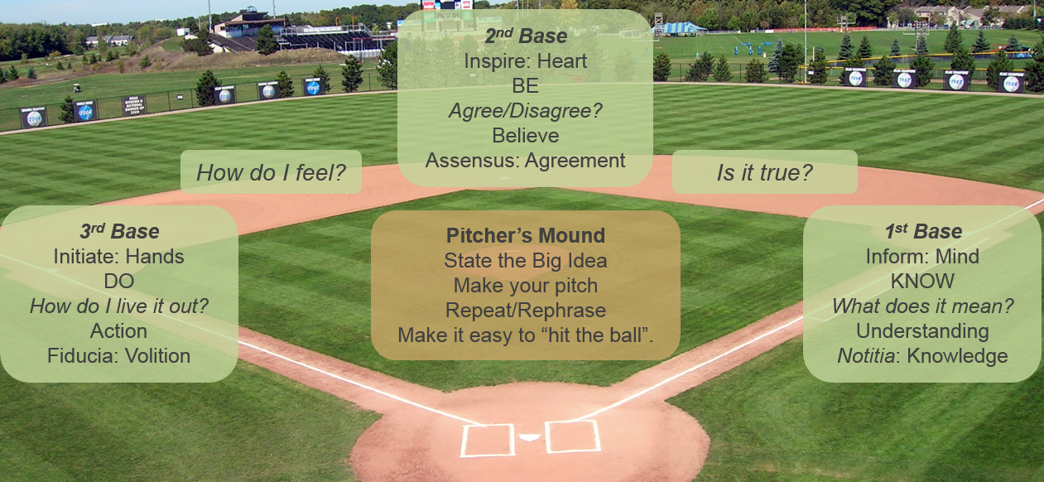

As A result of this Sermon I want my listeners to ______________________.
(Know, Be, Do)

Questions to help put it all together?

How will I present the message? *Structure

How will I shed light on the message? *Illustrations

How will I begin? *Introductoion

How will I end? *Conclusion

Am I missing anything? Look at Communication Coaching Form

Is my message Clear, Comprehensive and Compelling?

POINT? *Can I state the point of the message in a complete sentence?

PURPOSE? *As a result of the message, what do I want my listeners to do?

